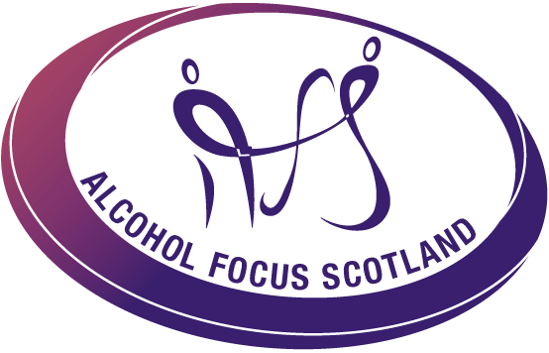


Wednesday 25th March 2015 (1.30PM – 5PM) Lecture Theatre
Clinical Skills

Western Isles Hospital

WORKPLACE ALCOHOL AND DRUGS WORKSHOP

The Scottish Centre for Healthy Working Lives in partnership with Alcohol Focus Scotland and Scottish Drugs Forum has developed a half–day training programme which is designed to give information and guidance to employers to help deal with workplace issues on both alcohol and drugs.
The sessions will enable employers/ managers to create a greater awareness around alcohol and drugs in their workplace and provide them with the knowledge and skills to deal with issues as they arise.

On completion of the training course, participants will have:
- Increase knowledge of the impact of alcohol and drugs on the workforce
- Increased knowledge of all forms of substances and their impact on the individual and workplace
- Increased awareness of the legal framework within which to implement workplace alcohol and drugs policies
- Increased awareness of development and implementation of alcohol and drugs policies
- Increased confidence in dealing with staff issues around alcohol and drugs

The sessions are delivered by Alcohol Focus Scotland and will be held in the Lecture Theatre, Clinical Skills, Western Isles Hospital, Stornoway.

To book a place for this workshop please contact Norma MacLeod:
Email norma.macleod1@nhs.net or Tel 01851 762013

Did you know that the ‘sickies’
people take
because of hangovers total around 640,000 lost working days each year?

Or that around 25% of workplace accidents are thought to
involve alcohol?

